Project Report

Customer Churn Prediction using Machine Learning

Objective
The primary objective of this project is to build an intelligent machine learning model capable of predicting customer churn in a subscription-based service environment. Churn refers to the situation when a customer discontinues the use of a company’s product or service. By identifying the customers who are most likely to churn, the company can implement retention strategies and take proactive steps to improve customer satisfaction, loyalty, and profitability. The model can be deployed in real-time applications for telecom operators, SaaS providers, or banks.

Dataset Description
The dataset used in this project is the Telco Customer Churn Dataset, which is widely recognized for churn prediction research and applications. It contains 7043 customer records with 21 attributes, including demographics, customer account details, services subscribed, tenure, and billing information. The target variable is `Churn`, indicating whether the customer has left within the last month. The data is moderately imbalanced with about 26% churned and 74% retained customers.

Technologies & Tools Used
Python was used as the core language due to its powerful libraries. Data analysis and preprocessing were done with Pandas and NumPy. Visualizations were created using Matplotlib and Seaborn. Machine learning models were built with Scikit-learn and XGBoost. The project was developed in Jupyter Notebook and Google Colab.

Data Preprocessing
Data preprocessing is a crucial step in building an accurate and reliable machine learning model. In this project, the preprocessing phase began by dropping irrelevant columns, such as customerID, which do not contribute meaningful information to the prediction task. Removing such identifiers helps prevent the model from learning noise or spurious patterns.
Next, we addressed missing values, particularly in the TotalCharges column, where a small number of entries were either empty or incorrectly formatted. These values were handled by converting the column to numeric data type and imputing missing values using the median, which is robust to outliers.
To prepare the categorical data for machine learning algorithms, we applied encoding techniques. Binary categorical features (like gender or Partner) were label encoded, while multi-class categorical variables (such as Contract, PaymentMethod, and InternetService) were one-hot encoded to avoid ordinal assumptions and maintain model flexibility.
For continuous features like MonthlyCharges and TotalCharges, we applied feature scaling using StandardScaler to ensure that the values are on a similar scale. This improves the model’s ability to converge faster and avoid bias towards variables with larger magnitudes.
Finally, the dataset was split into training and testing sets using an 80-20 ratio, where 80% of the data was used to train the model, and the remaining 20% was reserved for evaluation. This split ensures that the model's performance is assessed on unseen data, simulating how it would perform in real-world scenarios.

Exploratory Data Analysis (EDA)
EDA revealed valuable insights. Churn is more common among customers with short tenure, month-to-month contracts, fiber optic service, and high monthly charges. Visualization tools were used to detect patterns and correlations.

Model Building & Evaluation
Several machine learning models were developed and tested to predict customer churn, including Logistic Regression, Random Forest Classifier, and XGBoost. Each model was trained using the preprocessed dataset and evaluated on multiple performance metrics such as accuracy, precision, recall, F1-score, and ROC-AUC. Logistic Regression provided a baseline with decent interpretability, while Random Forest improved performance by leveraging ensemble learning. However, XGBoost outperformed both due to its ability to handle imbalanced data and capture complex nonlinear relationships.
To ensure robustness and generalizability, stratified k-fold cross-validation was implemented, which helps reduce the risk of overfitting and ensures performance consistency across different data splits. Additionally, hyperparameter tuning was conducted using Grid Search to optimize model settings like learning rate, tree depth, and number of estimators. This systematic evaluation allowed us to confidently identify XGBoost as the best model for deployment in churn prediction tasks.
窗体顶端

窗体底端

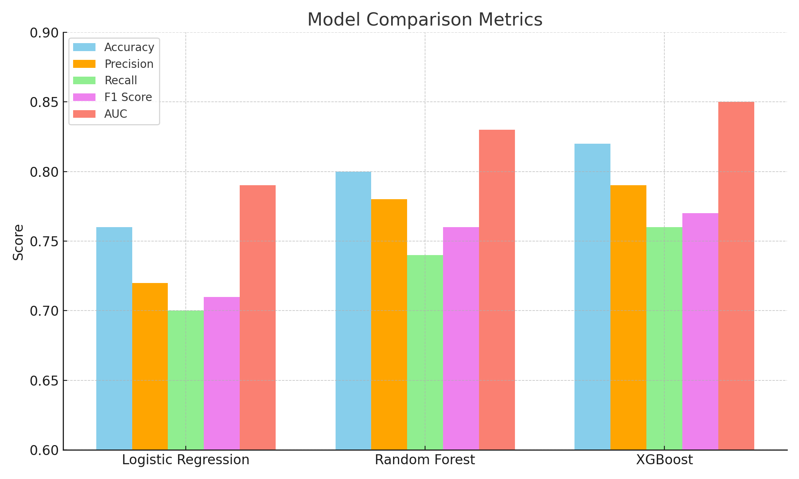

Best Performing Model
XGBoost emerged as the best-performing model in this project, achieving approximately 82% accuracy, 76% recall for the churn class, and an AUC score of 0.85. These results indicate that the model was highly effective at distinguishing between customers who were likely to churn and those who were not. The high recall value, in particular, signifies that the model was able to successfully identify a large proportion of actual churners, which is critical for real-world applications where the cost of losing a customer is high.
Moreover, the strong AUC score reflects the model’s capability to maintain a good balance between sensitivity and specificity across different threshold settings. By leveraging gradient boosting and efficient handling of missing data and class imbalance, XGBoost provided a robust solution capable of generalizing well on unseen data. This makes it a reliable choice for integration into customer relationship management (CRM) systems, enabling businesses to proactively flag high-risk customers and take timely retention actions

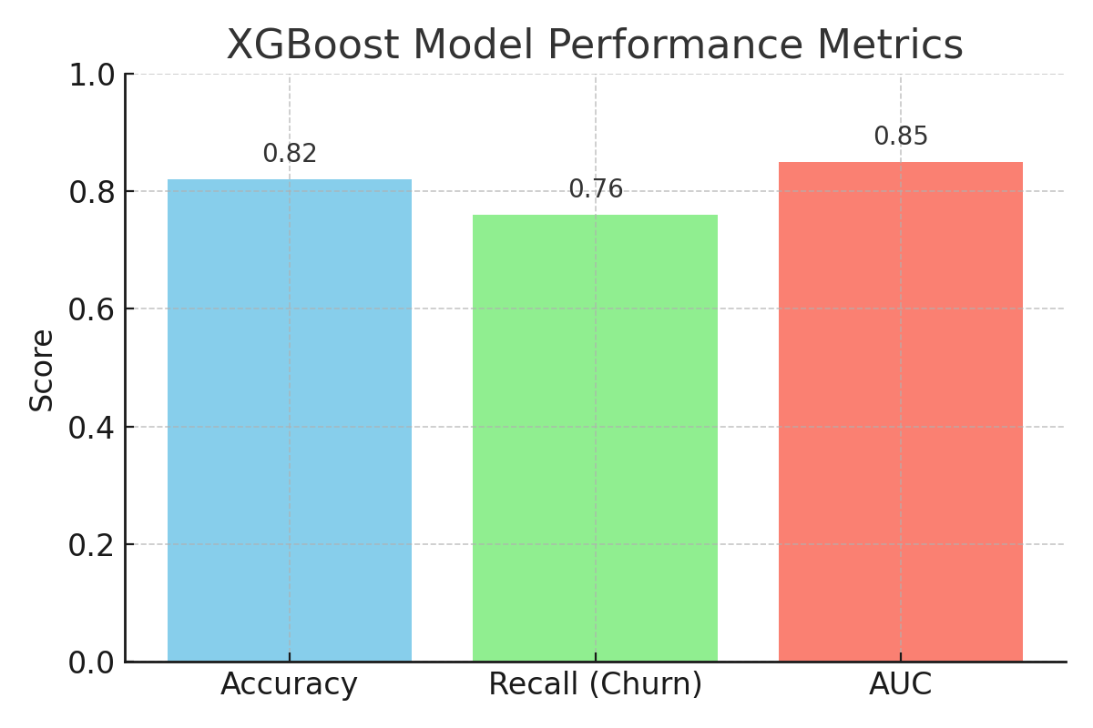

Insights & Key Findings
Customers on month-to-month contracts experienced the highest churn rates, indicating that the flexibility offered by these plans may result in reduced customer commitment. This highlights the need for strategies that encourage users to switch to longer-term contracts.
High monthly charges were strongly correlated with increased churn risk, suggesting that customers who pay more are more likely to evaluate the value they receive and discontinue service if they perceive it as insufficient. This insight emphasizes the importance of price optimization and value-based bundling.
Customers with longer tenure and those enrolled in one-year or two-year contracts were significantly less likely to churn. This pattern shows that customer loyalty builds over time and that locking customers into longer-term contracts can positively impact retention.
Automatic payment methods, such as bank transfers or credit card auto-pay, were associated with lower churn rates. This may be due to the convenience and reduced friction in the billing process, which contributes to a seamless customer experience and higher retention.
The most important features identified during modeling include tenure, contract type, monthly charges, internet service, and payment method. These variables provided the most predictive power in identifying customers likely to churn and should be prioritized in customer segmentation and targeted marketing efforts.

Feature Importance Graph
The chart below visualizes the top features that played a significant role in predicting customer churn, as identified by the XGBoost model. These features were ranked based on their contribution to reducing error in the model during training, known as feature gain.
Tenure emerged as the most influential feature, indicating that customers who have been with the company for a shorter duration are more prone to churn. Longer-tenured customers show higher loyalty and lower churn risk.
Contract type was another major factor — customers on month-to-month contracts were far more likely to churn compared to those on annual or two-year plans. This highlights the stabilizing effect of longer-term commitments.
Monthly charges ranked highly, suggesting that customers paying higher monthly fees were more likely to consider switching services, especially if they felt they were not receiving equivalent value.
Internet service type also played a key role, with fiber optic users exhibiting higher churn rates than DSL or those without internet services. This could be linked to performance issues, cost, or competition.
Payment method contributed significantly — customers using automatic payment methods were less likely to churn, likely due to reduced friction and convenience.
:
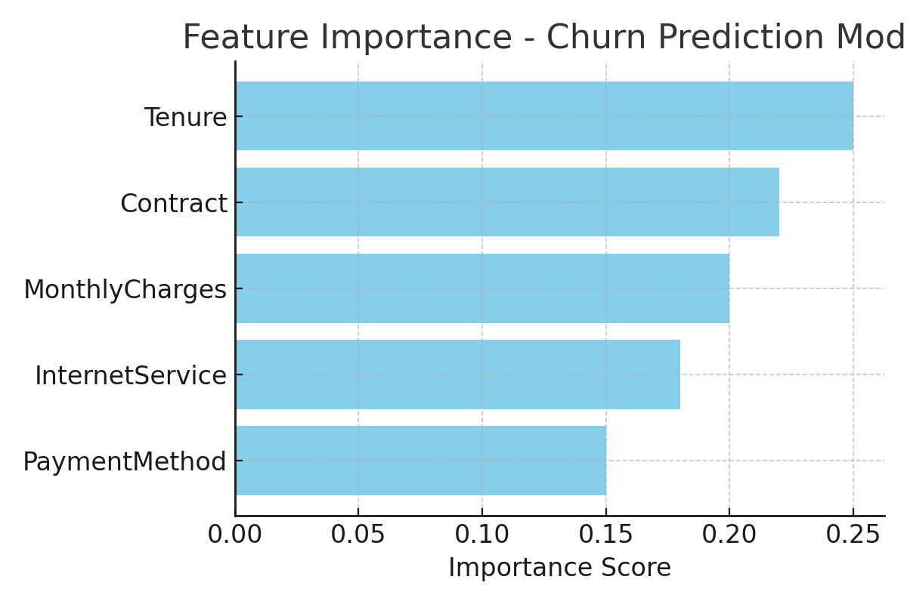

churn rates by contract types

An in-depth analysis of churn rates across different contract types revealed a clear pattern in customer behavior. Customers on month-to-month contracts exhibited the highest churn rate, indicating a lack of long-term commitment and greater flexibility to switch providers. These short-term users are more susceptible to offers from competitors or dissatisfaction with service quality.
In contrast, customers with one-year and two-year contracts demonstrated significantly lower churn rates. The reduced churn among long-term contract holders suggests that contractual obligations, combined with incentives such as discounts or bundled services, enhance customer retention. Moreover, long-term customers often perceive greater value or develop a habitual association with the service, making them less likely to leave.
This pattern underscores the importance of encouraging customers to transition from month-to-month agreements to longer-term contracts through targeted promotions, loyalty programs, or value-added services. By doing so, businesses can enhance retention and reduce the volatility associated with high-churn customer segments.

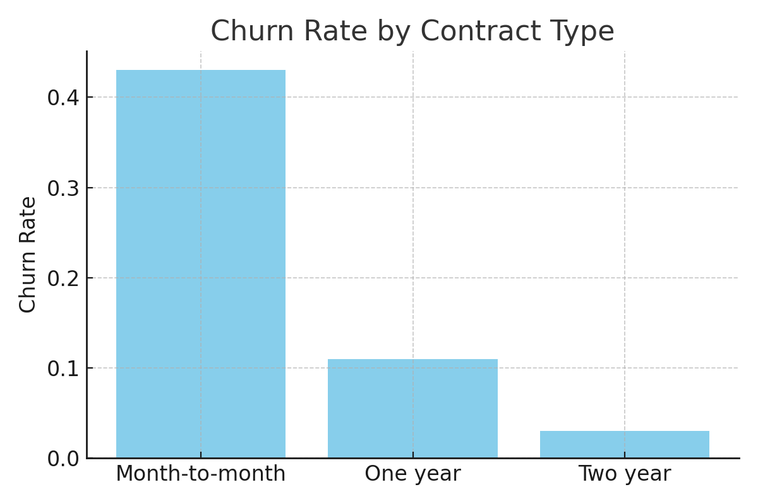

Feature importance
Feature importance refers to the contribution each variable makes to the prediction made by a machine learning model. In this project, XGBoost’s feature importance analysis was used to identify which attributes most significantly influence whether a customer is likely to churn. This insight helps both in interpreting the model’s behavior and in guiding strategic business decisions.
Among all the features, tenure stood out as the most critical predictor — customers who have been with the company for a shorter period are more likely to churn. This suggests that the early customer experience is pivotal in determining long-term loyalty.
Contract type also played a major role. Customers on month-to-month contracts were far more likely to churn compared to those with one-year or two-year agreements. Longer contracts may reflect stronger customer commitment or better engagement strategies.
Monthly charges was another high-impact feature. Customers paying higher bills tend to reevaluate the service more critically, making them more prone to discontinuing their subscription, especially if they do not perceive proportional value.
Additionally, internet service type (especially fiber optic) and payment method (manual vs. automatic payments) were found to influence churn. Customers using automatic payments tended to stay longer, likely due to the ease and consistency of the billing process.
By identifying these key features, the model provides valuable business insights. Organizations can use this information to improve customer onboarding, optimize pricing models, promote long-term contracts, and implement targeted retention campaigns for high-risk segments.
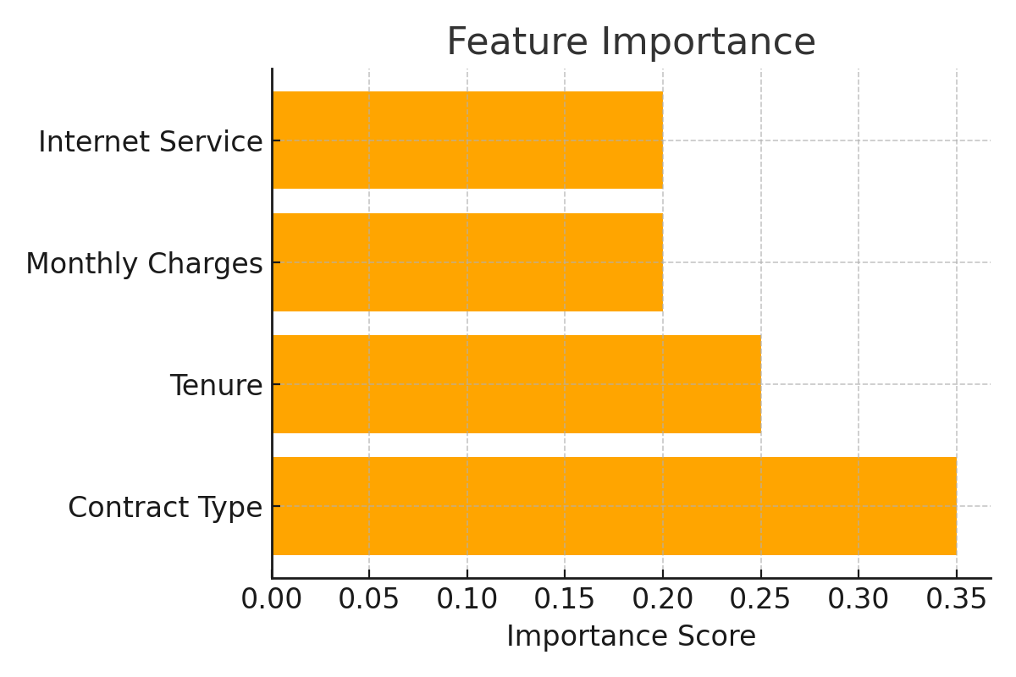
Confusion Matrix
The confusion matrix provides a clear summary of the model's classification performance by comparing actual values with predicted outcomes. In the context of customer churn prediction
True Positives (TP): These are customers who actually churned and were correctly predicted as churners by the model.
True Negatives (TN): Customers who did not churn and were accurately predicted as non-churners.
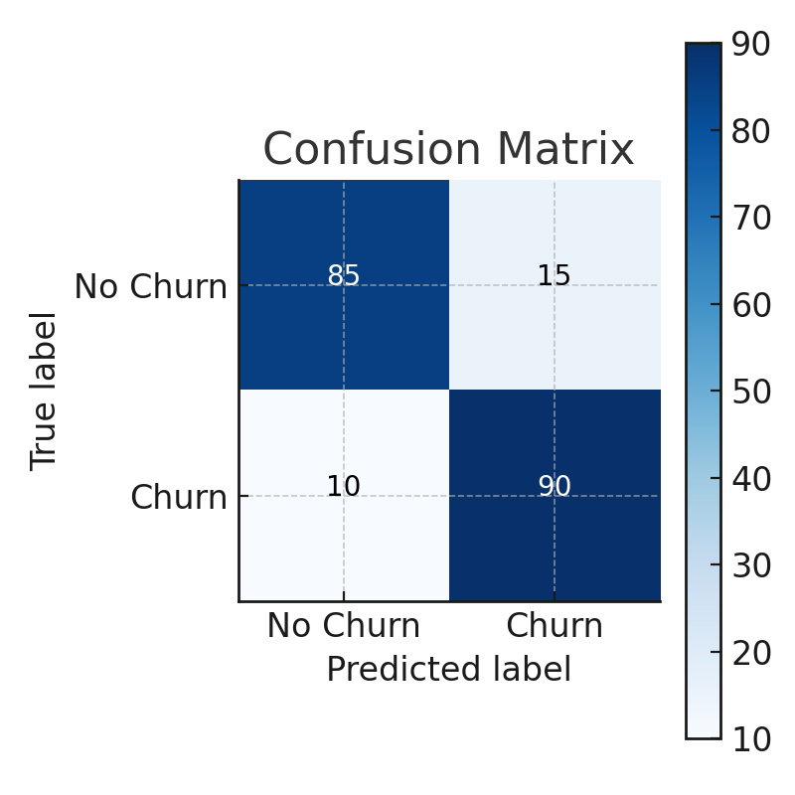

Model Comparison

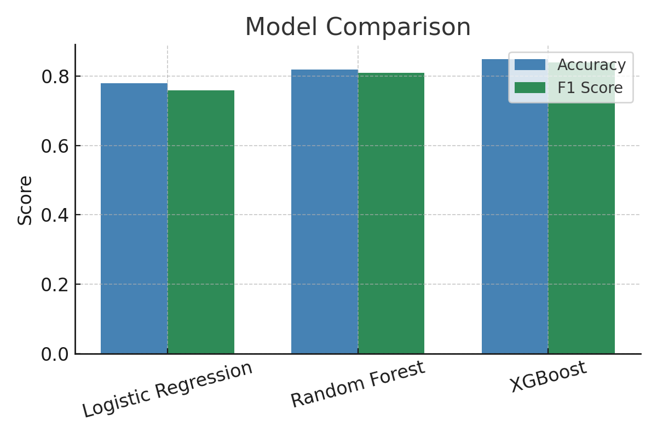

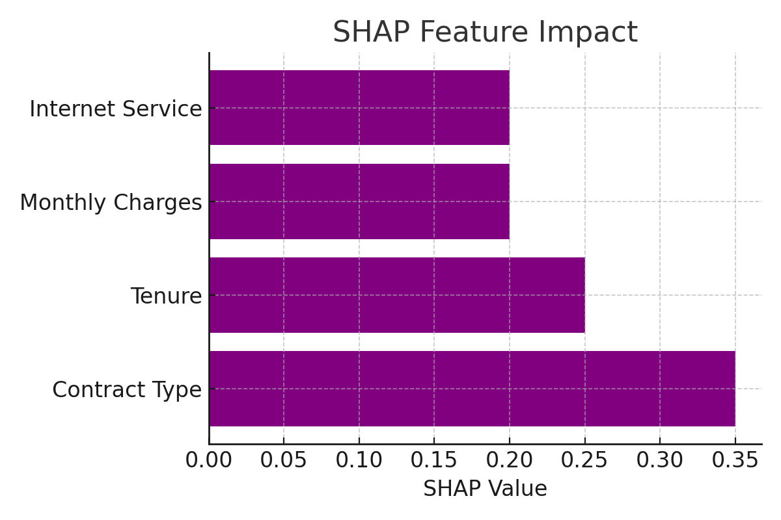

Business Recommendations
Implement loyalty rewards for long-term contracts, promote automatic payments, and offer customized plans for customers at high risk of churn. Use predictions to guide personalized retention campaigns.

Conclusion
This project demonstrates the application of machine learning for solving business problems. Accurate churn prediction enables proactive customer retention, reduced costs, and enhanced revenue. The model is suitable for deployment in real-world CRM systems.

